

AgentAssist

  - Release Note reference: Click or tap to enter a date.
  - Release test systems target: Click or tap to enter a date.
  - Release production target: Click or tap to enter a date.

Release Notes
TCS AgentAssist
Index
1 How to read this document 3
1.1 Purpose 3
1.2 Terminology 3
2 What’s new 5
2.1 New developments 5
2.2 Product fixes 5
3 New developments 6
3.1 Create Order 6
3.1.1 Search Criteria/Offer Search 6
3.1.2 Display list of Offers & Content 7
3.1.3 Terms & Conditions/Fare Rules 8
3.1.4 Select Offer 9
3.1.5 Passenger Information Details 10
3.1.6 Fare Breakdown 11
3.1.7 Order Creation without Payment 12
3.1.8 Search Ancillaries 13
3.1.9 Display & Select Ancillary 15
3.1.10 Ancillary Seatmap 16
3.1.11 Integrate with CRM Platform 17
3.1.12 Integrate with ARD Web 18
4 Product fixes 20
5 Where to get more info 20
5.1 Release Notes 20
5.2 User Guides 20

Document control
Security level | Confidential & Restricted
Company | Tata Consultancy Services
Unit | Industry Advisory TTH UK EMEA
Author | Balaji Bashyam
Version | Date | Change | Comment | By
1 | 05/05/2026 | Initial publication |  | Balaji Bashyam

How to read this document

Purpose
The purpose of the Release Note is to announce and describe the latest new enhancements of TCS Agent Assist. It also aims to highlight the new enhancements which require airline action to activate and provide brief instructions for access and adoption.
To know more about the application functionality, please refer to the user manual document: User Manual

Terminology
Feature types
- Mandatory features will be activated to ensure product performance as per design.
- Optional features may be activated or not depending on airline preferences. Some optional features are activated by default and enable a configuration to deactivate, while others can either be activated by airlines directly or by Amadeus upon airline request.
Feature qualifications
- Baseline features are included in the product for all customers at no additional charge.
- Premium features are optional and charged in addition to the baseline contract.
For Baseline or Premium features, there may be implementation fees that will be indicated with “Chargeable configuration update required”.
Activation types
New features are subjected to the following types of activation:
- Activated by default: no airline action required
- Configuration update required: airline action required
- Chargeable configuration update required: airline action required
Configuration types
For cases when an activation requires a configuration update, there are two types:
- Airline self-service: configuration update to be done directly by the airline
- Amadeus support: configuration update to be done by Amadeus upon airline request.
For cases when the configuration type is Airline self-service, the following updates should be done by the airline:
- LSS setup: Application, Role, Permission, and Data type
- Amadeus Business Rules: Create or update rules as required.
For cases when support from Amadeus is required the airline should submit a request using one of the following methods as indicated:
- Work Order: Create a Work Order in Amadeus Customer Service Point.
- Change Proposal: Create a Change Proposal in Amadeus Customer Service Point.
- Service Request: Request a service with “Configuration Request” category in MyAmadeus Services.
- Propose a change: Submit a change proposal in MyAmadeus Services.
- Airline Order Online: Request the implementation in Amadeus Airline Order Online.

What’s new

New developments
Module | Features | Type | Airline action? | Qualification
Create Order | Search Criteria/Offer Search | Mandatory | No | Baseline
 | Display list of Offers & Content | Mandatory | No | Baseline
 | Terms & Conditions/Fare Rules | Mandatory | No | Baseline
 | Select Offer | Mandatory | No | Baseline
 | Passenger Information Details | Mandatory | No | Baseline
 | Fare Breakdown | Mandatory | No | Baseline
 | Order Creation without Payment | Mandatory | No | Baseline
 | Search Ancillaries | Mandatory | No | Baseline
 | Display & Select Ancillary | Mandatory | No | Baseline
 | Ancillary Seatmap | Mandatory | No | Baseline
 | Integrate with CRM Platform | Mandatory | No | Baseline
 | Integrate with ARD Web | Mandatory | No | Baseline

Product fixes
This section is not applicable for this delivery.

New developments

Create Order

Search Criteria/Offer Search
Type | Mandatory | Qualification | Baseline
Activation type | Activated by default

Activation details
This feature will be activated by default by TCS.

Configuration/Customization Options
The following criteria can be configured through admin console pertaining to Search Criteria:
- Origin & Destination
- Fare families per cabin types
- Trip types
- PoS/Market
- CFF
- Frequent flyer program
- Language
- Currency
- Operating carriers
- Shopping types
- PTC with age range
- PTC with discount code
- No. of passengers’ count

Main benefits
Offering customers flights from various O&Ds, giving them flexibility to choose from parameters such as currency, language, PTC, trip type, cabin, FFP, etc. All of these can be configured by agents via an Admin Console.

Functional description
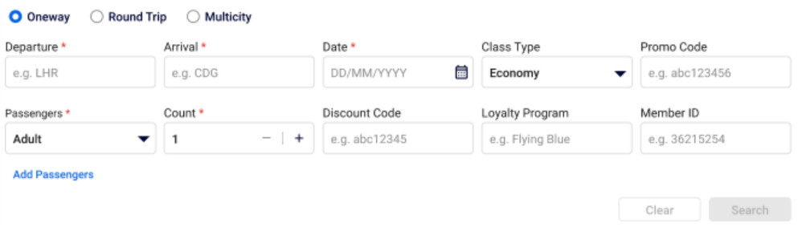
Figure 1: Panel for Offer Search/Search Criteria

The Search Panel is the interface for agents to search for flight offers based on configurable criteria such as trip type, origin/destination, travel dates, passenger details, cabin class, and optional data like promo codes, loyalty programs, and discount codes.

Display list of Offers & Content
Type | Mandatory | Qualification | Baseline
Activation type | Activated by default

Activation details
This feature will be activated by default by TCS.

Main benefits
Agents will be able to see the offer results as per search criteria. They will be able to filter and sort offers, view itinerary level information (O&D, Departure & Arrival time and date, etc.), cabin types, sellable fare families which will help them choose offers for customers.

Functional description
When all mandatory criteria in the Offer Search Panel are entered and validated, the system conducts the search. The system retrieves flight offers matching the defined criteria and displays them for review.
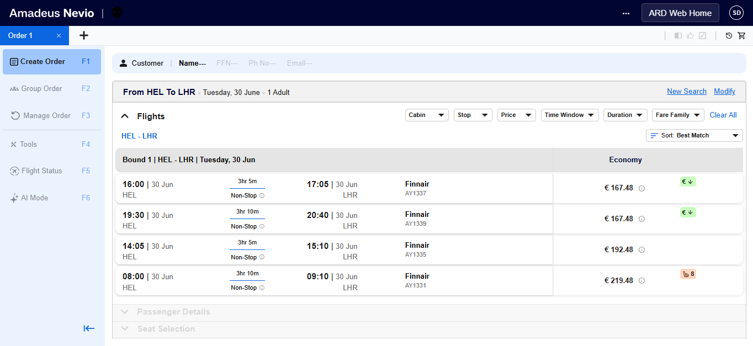
Figure 1: Displaying of offers

Terms & Conditions/Fare Rules
Type | Mandatory | Qualification | Baseline
Activation type | Activated by default

Activation details
This feature will be activated by default by TCS.

Main benefits
T&Cs associated with each flight offer per bound, will help agents clearly communicate the fare rules to the customer, which in turn will help them make informed decisions pertaining to their flights.

Functional description
If Offer pertaining to search criteria are found, then list of Terms & Conditions is presented to the agent which must include:
- Change policies, Penalties
- Refund and cancellation policies
- No Show Policy
- Baggage Allowance
- Restrictions, etc.
Note: Terms & Conditions vary per PTC

Select Offer
Type | Mandatory | Qualification | Baseline
Activation type | Activated by default

Activation details
This feature will be activated by default by TCS.

Main benefits
- Accurate booking decisions by reviewing itinerary and fare details before checkout
- Better customer outcomes by quickly replacing offers based on customer instructions
- Faster, cleaner workflows by discarding unwanted offers in real time
- On‑time bookings by tracking offer expiry and completing orders before validity lapses
- Reduced booking and payment errors by preventing selection of expired or invalid offers
- Clear customer communication with complete, up‑to‑date fare and itinerary visibility
- Easy correction of passenger details to fix mistakes without restarting the flow

Functional description
This functionality enables the system to manage flight offers through a cart-based workflow, allowing agents to add, replace, or remove selected flight offers while browsing. Each offer in the cart is tracked with a visible validity time or expiration counter, and the system continuously validates offers in real time—automatically detecting, notifying, and blocking expired offers from further action. The cart is refreshed whenever offers are selected, passenger details are added or updated, or other key actions occur, ensuring prices, availability, and rules remain valid. Passenger (PAX) information can be added or edited directly in the cart, triggering revalidation when required. The system supports viewing cart totals in different currencies by recalculating amounts using applicable exchange rates without compromising offer validity. Before checkout, all flight offers are revalidated to prevent booking or payment errors. Once an order is successfully created, the cart is automatically cleared to avoid duplicate or accidental reuse.

Passenger Information Details
Type | Mandatory | Qualification | Baseline
Activation type | Activated by default

Activation details
This feature will be activated by default by TCS.

Main benefits
- Accurate passenger data capture to ensure all mandatory travel details are correctly recorded
- Timely airline–customer communication by enabling airlines to send booking confirmations, alerts, and travel updates
- Regulatory compliance with international and domestic travel requirements through capture of mandatory identification and travel data
- Support for alternative identification to accommodate domestic travel rules or specific regulatory scenarios
- Improved data quality and reduced errors through validation and editable passenger information
- Faster booking completion by allowing agents to correct mistakes without re-entering passenger information
- Customer loyalty enablement by capturing frequent flyer details to allow earning of points or miles

Functional description
This functionality enables the system to capture, validate, and manage complete passenger and contact information required for booking. Agents can enter details for each passenger, including mandatory contact information for at least one adult, emergency contacts, and travel documents such as passport, visa, or national ID when required. Passenger data is validated using airline‑configured rules covering PTC age limits, email formats, and country‑specific mobile number patterns, with airlines able to define which fields are mandatory, optional, or validation‑driven. The system supports updating passenger and contact details without re‑entry when offers change, capturing loyalty program information, assigning infants to adult passengers, and bulk uploading passenger and contact data to speed up bookings while maintaining accuracy and compliance.
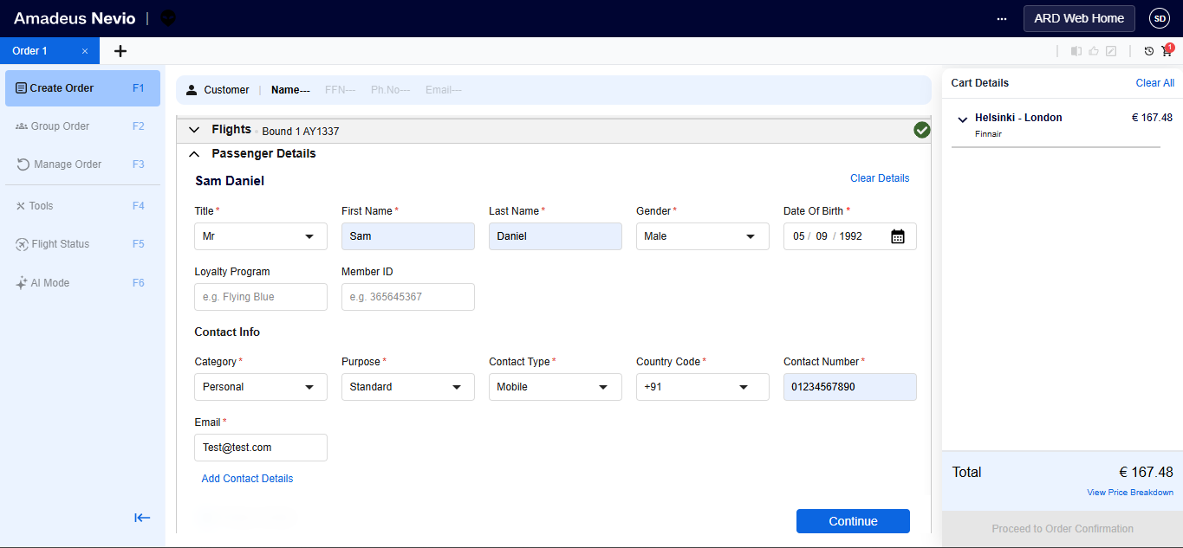
Figure 1: Entering Passenger Information Details

Fare Breakdown
Type | Mandatory | Qualification | Baseline
Activation type | Activated by default

Activation details
This feature will be activated by default by TCS.

Main benefits
- Transparent pricing communication enables agents to clearly explain the full fare structure to customers, building trust and confidence.
- Clear tax and fee breakdown visibility helps customers understand each charge, reducing confusion and disputes.
- Accurate total charge visibility ensures agents know exactly what amount the customer will be charged, minimizing billing errors and post‑booking issues.

Functional description
This functionality enables the system to present a clear and detailed price breakdown for each flight offer, including base fare, taxes, fees, surcharges, and other applicable components, with all amounts displayed in the pricing currency selected. The breakdown is shown per Passenger Type Code (PTC), recognizing that fare components, taxes, and surcharges may vary by passenger type. In addition, the system provides a total fare summary in the selected currency, ensuring agents have full visibility into both individual components and the final amount payable by the customer.

Order Creation without Payment
Type | Mandatory | Qualification | Baseline
Activation type | Activated by default

Activation details
This feature will be activated by default by TCS.

Main benefits
- Seamless remote payment facilitation, enabling agents to collect payments
- Customer‑preferred delivery of payment links (email, SMS, or both), improving payment convenience
- Proactive payment reminders helping agents notify customers before payment expiry
- Greater payment success by allowing agents to extend payment time without losing the order
- Flexible offer revision support so agents can adjust offers and pricing before payment, based on customer changes
- Full pricing transparency with clear visibility of total fare, fare breakdown, and applied discounts, reducing disputes
- Real‑time payment tracking allowing agents to see whether payment is completed, pending, or failed
- Clear order status visibility at both order and item level (flight, seats, baggage, meals) for effective servicing

Functional description
This functionality enables end‑to‑end payment link generation and order visibility for an inprogress order. The system shall allow agents to generate a secure payment link for the current order and deliver it to customers via email, SMS, both, or an alternate email address, as configured by the airline, including existing passenger contacts. Agents must be able to regenerate a payment link, which automatically invalidates any previous link, and the system shall display a countdown timer indicating the payment time limit. The system shall handle payment timeouts, allow agents to extend the payment time limit for unpaid orders when permitted, and require generation of a new payment link if the offer or cart is modified, resulting in price changes. Additionally, the system shall provide a comprehensive order summary, including Record Locator (PNR), detailed fare component breakdown, order creation details, payment status and remaining payment time, as well as clear visibility of order‑level and order‑item‑level statuses for tracking and post‑booking servicing.

Search Ancillaries
Type | Mandatory | Qualification | Baseline
Activation type | Activated by default

Activation details
This feature will be activated by default by TCS.

Configuration/Customization options
The system shall provide an airline-configurable ancillary and SSR management framework accessible only to authorized users, enabling administrators to create, update, and delete SSR codes and their associated categories while preventing duplicate SSR code entries. Administrators shall also be able to configure the service catalogue by defining categories and sub-categories, mapping each ancillary/service to one or more Passenger Type Codes (PTCs), setting Active/Inactive status, defining the display order of categories and services, and specifying quantity selection and maximum capacity limits where applicable; inactive services (or services under disabled categories) shall not be displayed and must be disabled accordingly in both quick access and custom views.

Main benefits
- Faster and flexible SSR management by allowing easy configuration and updates across categories without code changes
- Improved compliance and accuracy by ensuring agents offer only PTC‑eligible services (Adult, Child, Infant)
- Better agent efficiency and usability by displaying only relevant ancillary services for each customer booking
- Simplified service management by enabling easy visibility and handling of related services together

Functional description
The system shall support ancillaries offered at the appropriate level (e.g., bound/segment-level or flight-level) based on configuration and shall allow agents to retrieve all applicable ancillaries using a valid Cart Reference ID, returning a structured, grouped list containing each ancillary’s type, description, price, and quota/availability as provided by APIs and filtered by cart eligibility (e.g., PTC, flight/segment identifiers). Only ancillaries mapped to the relevant PTC(s) shall be visible and selectable for that passenger type, and if no ancillary services are available for the cart, the system shall display a clear message indicating that no ancillaries exist. Configuration changes shall take effect in real time or on the next system refresh, as supported by the platform.

Display & Select Ancillary
Type | Mandatory | Qualification | Baseline
Activation type | Activated by default

Activation details
This feature will be activated by default by TCS.

Main benefits
- Clear visibility of included services vs add‑ons, helping agents quickly explain what is part of the offer
- Accurate pricing communication for all selected services, reducing confusion and disputes
- Precise baggage selection by clearly presenting the most suitable options per passenger
- Personalized service offerings tailored to individual passenger preferences and needs
- Ability to upsell relevant add‑on services before checkout in a controlled manner
- Full review of selected ancillaries before order confirmation
- Transparent total cost visibility of ancillaries prior to payment
- Easy order updates to reflect last‑minute passenger preference changes without recreating the booking

Functional description
The system shall display all applicable ancillaries/services for the selected offer/flight retrieved from the service catalogue, grouped by airline-configured categories (e.g., Baggage, Meals, Lounge) and filterable by pricing type (Free vs Chargeable). Each ancillary shall show name/description and a price label in the correct booking currency, where any ancillary without a price must be marked as FREE; baggage services shall be presented as a list of available baggage options with prices varying by passenger type and segment, allowing agents to select services per passenger and per segment/bound where applicable. The user shall be able to select one or more ancillaries, specify and update quantities (default 1) within configured limits. The system shall allow users to proceed without selecting any ancillary (with a non-blocking confirmation), retain selected ancillaries when moving to the next step, and validate price/availability/quota in real time before confirming selection; upon confirmation, the system shall add the selected ancillaries to the cart via /v2/shopping/carts/{cartId}/services, display success/failure messages (including no selection, system failure, or price fetch failure), and show selected ancillaries in the cart grouped per passenger per segment with unit price, quantity, and total amounts in booking currency. The system shall support post-addition servicing by allowing agents to modify ancillary quantities/details or delete ancillaries from the cart (with deletion confirmation), revalidating availability and updating totals accordingly, and presenting clear error messages if modification or removal cannot be completed.

Ancillary Seatmap
Type | Mandatory | Qualification | Baseline
Activation type | Activated by default

Activation details
This feature will be activated by default by TCS.

Main benefits
- Clear visibility of included services vs add‑ons, helping agents quickly explain what is part of the offer
- Accurate pricing communication for all selected services, reducing confusion and disputes
- Precise baggage selection by clearly presenting the most suitable options per passenger
- Personalized service offerings tailored to individual passenger preferences and needs
- Ability to upsell relevant add‑on services before checkout in a controlled manner
- Full review of selected ancillaries before order confirmation
- Transparent total cost visibility of ancillaries prior to payment
- Easy order updates to reflect last‑minute passenger preference changes without recreating the booking

Functional description
This functionality enables agents to view and select seats as an optional ancillary during booking by retrieving and displaying real-time seat maps per flight segment, applying eligibility rules, and ensuring selected seats are reflected consistently across the cart and order summary. The system shall retrieve the seat map for each segment included in the selected offer and render the aircraft layout for that segment only, showing seat status as Available, Occupied/Unavailable, Blocked, and Special (e.g., extra legroom, exit row) with clear visual markers or color coding. Seat details (seat number, seat type, attributes such as window/aisle, and price where applicable) shall be displayed on hover or selection, using seat characteristics returned by the seat map API; paid seats must show the price in booking currency, while non-chargeable seats are labeled FREE. Seat availability and pricing shall be sourced from the existing seat inventory and kept real-time, with the system validating availability before confirming any seat assignment.
Seat selection shall be exposed under the Services category and allow agents to assign seats per passenger per segment, with all passengers visible and selectable on the seat map and the ability to switch between segments easily. The system shall display any current/pre-assigned seats and ensure any pre-selected seat services remain correctly linked to the relevant segment. Business rules must be enforced, including restricting exit row seats for non-ADT passengers (e.g., CHD). If a seat is not selected for a segment, the system shall indicate “Seat not assigned / No seat selected” and optionally notify the agent when moving to the next step, while still allowing the agent to proceed and create the order without seat selection (seat selection is optional and can be bypassed).

Integrate with CRM Platform
Type | Mandatory | Qualification | Baseline
Activation type | Activated by default

Activation details
This feature will be activated by default by TCS.

Main benefits
- Uninterrupted agent productivity by eliminating the need for repeated logins through seamless SSO access
- Faster and seamless access to SCUI directly from CRM without manual navigation or re‑authentication
- Reduced manual data entry by auto‑populating customer information from CRM, improving speed and accuracy
- Quicker and more accurate booking creation using prefilled customer details

Functional description
This functionality enables seamless CRM and SCUI integration using SSO and secure data exchange. When an authenticated agent launches SCUI from CRM (in a new tab or embedded view as configured), SCUI shall not prompt for additional login and shall validate the agent session via SSO, landing the agent directly in SCUI; if the CRM session is invalid or expired, the agent shall be prompted to re-authenticate and the launch must fail gracefully with a clear error message if it cannot be completed. Once a customer record is identified in CRM, SCUI shall automatically retrieve customer details (e.g., first name, last name, email, phone, frequent flyer number) and auto-populate them into the booking creation flow, allowing the agent to review and edit the prefilled fields. If CRM data is missing, incomplete, or retrieval fails, SCUI shall display a clear indicator/message, allow manual entry or update where permitted, enforce mandatory-field validation before saving/proceeding, and ensure the booking flow continues without being blocked due to partial CRM data, while adhering to applicable security and data governance policies and ensuring end-to-end integration works seamlessly across CRM and ARDWeb.

Integrate with ARD Web
Type | Mandatory | Qualification | Baseline
Activation type | Activated by default

Activation details
This feature will be activated by default by TCS.

Main benefits
- Uninterrupted workflow by eliminating multiple logins through seamless SSO access
- Smooth task continuity with direct navigation between SCUI and ARDWeb without manual steps
- Auto‑loaded booking context in ARDWeb, saving time by avoiding manual PNR search
- Clear operational guidance when features are unavailable, enabling agents to proceed via alternative processes
- Seamless payment processing through direct redirection to ARDWeb

Functional description
This functionality enables seamless navigation and deep linking between SCUI and ARDWeb using SSO, without requiring agents to re‑enter credentials. Agents can launch ARDWeb directly from SCUI—via a global link, order details page, or a contextual “To Pay” action—opening ARDWeb in a new browser tab and landing successfully on the configured homepage or payment flow. When initiated from order or payment contexts, the system securely passes the selected PNR and office ID, allowing ARDWeb to automatically load the corresponding order details without manual re‑entry; appropriate, actionable error messages are shown if PNR loading or redirection fails. The global ARDWeb link remains accessible from all SCUI screens and can also open ARDWeb in a fresh, independent session (without passing SCUI context) where configured, without impacting the active SCUI session. Additionally, SCUI provides configurable global info blocks to clearly indicate when features are unavailable, offering concise, consistent guidance on alternative actions that can be maintained without code changes.

Product fixes
Not applicable – This will be the debut release.

Where to get more info

Release Notes
Last published: NA
Upcoming:
TCS AgentAssist has tentatively scheduled the following dates for upcoming Release Notes.
[Remove the column for “Walkthrough date” if your product does not host regular sessions with customers to explain new releases].
Planning Increment | Duration | Publication date | Walkthrough date
#YY.1 (1Q) | January - March | [29th February] | [07th March]
#YY.2 (2Q) | April - June | [20th June] | [27th June]
#YY.3 (3Q) | July - September | [13th September] | [20th September]
#YY.4 (4Q) | October - December | [5th December] | [12th December]
Note: dates for upcoming publications are tentative and subject to change.

User Guides
The AgentAssist User Guide provides a comprehensive set of descriptions for all available modules and capabilities, plus how to activate, configure, customize, and use them.
User Manual
Be sure to review the What’s New section to see what’s changed from the previous edition.

